Dear Provider,

As part of our continuous efforts to be customer centric and in line with our brand guidelines – we are pleased to launch the new SAICOHEALTH insurance ID cards.

The new cards will be issued effective **January 1st, 2017**. However the existing SAICOHEALTH Gold cards will remain effective till renewal date.

**New SAICOHEALTH Card Designs for existing GOLD cards**





The cards also clearly show the SAICOHEALTH network tier that the member is entitled to access. **Gold, Amber, Bronze, Emerald, Jade (only in UAE)**

Your facility falls under the (Emerald) network and therefore you can accept medical cards that have the word (Gold, Amber, Bronze & Emerald).

If you receive a member whose card features other network tiers, please direct them to call SAICOHEALTH. We will assist them with finding a provider within their tier.

**Existing SAICOHEALTH Card Designs**

Meanwhile, please continue accepting members holding the current Gold card up to the policy expiry date – given that their coverage allows them to access your facility.

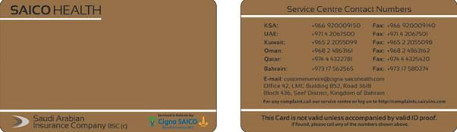

**New SAICOHEALTH KSA Card Designs**



The KSA cards have the same look and feel as non-KSA cards; however we kept the cards gold in colour per the market preference. KSA card holders will be eligible for direct billing at your facility regardless of the assigned network.

Everything else with regards to the administration of the plan stays the same as before. Should you have any further queries, please contact your network administrator at SAICOHEALTH at [wkhoury@cigna-saicohealth.com](mailto:wkhoury@cigna-saicohealth.com) . You may also call us on +971 4275 2467.

Please note that the care and service of SAICOHEALTH customers is of utmost importance and we urge you to handle all members with care and sensitivity whilst managing this change.

Sincerely,

The SAICOHEALTH team