Dear Provider,

As part of our continuous efforts to be customer centric and in line with our brand guidelines - we are pleased to announce the replacement of our existing Silver cards with Gold cards upon policy renewals.

As you are aware, Saicohealth currently has Gold (gold class & blue class) and Silver colored cards, this switch will allow us to unify the cards under one color (Gold) with “Class” being the differentiating factor among the policies and benefits for the members.

Current silver cards can only be accepted by a provider if they received a GAA from Saicohealth stating that the group mentioned is eligible for direct billing at their facility. Moving forward, all Silver cards will be replaced by Gold cards maintaining the same previous eligibility as per the GAAs sent earlier. Should your facility be no longer eligible a notice e-mail will be sent across to you.

Silver cards will be replaced with Gold cards mentioning one of the following classes:
- A
- A+
- A1
- VIP
- VIP+
- B
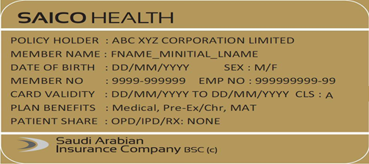

Meanwhile, please continue accepting members holding the current Silver card up to the policy expiry date – given that their coverage allows them to access your facility.

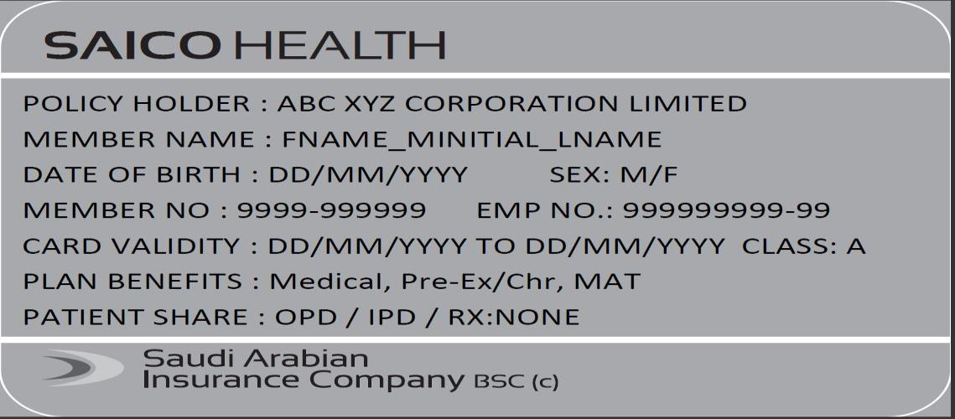

Everything else with regards to the administration of the plan stays the same as before. Should you have any further queries, please contact your network administrator at SAICOHEALTH at wkhoury@cigna-saicohealth.com

Please note that the care and service of SAICOHEALTH customers is of utmost importance and we urge you to handle all members with care and sensitivity whilst managing this change.

Sincerely,
The SAICOHEALTH team

